**EX.NO:03 UML DIAGRAM FOR ONLINE VOTING SYSTEM**

**USE CASE DIAGRAM**

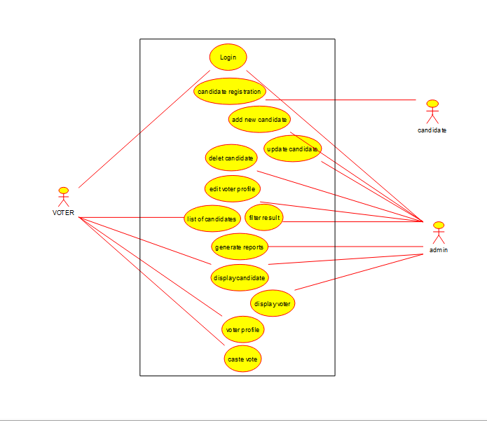

**CLASS DIAGRAM:**

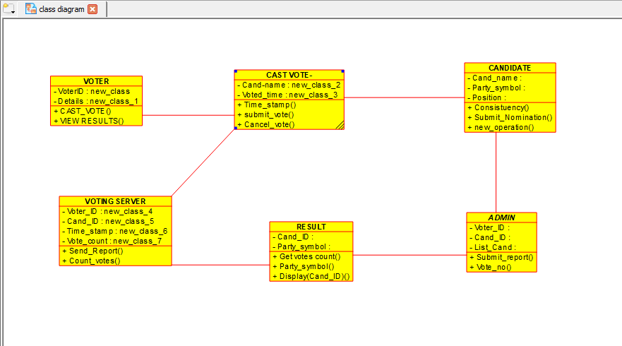

**ACTIVITY DIAGRAM:**

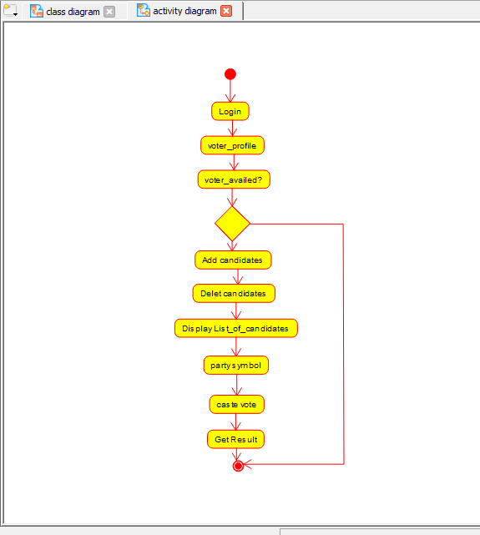

**SEQUENCE DIAGRAM:**

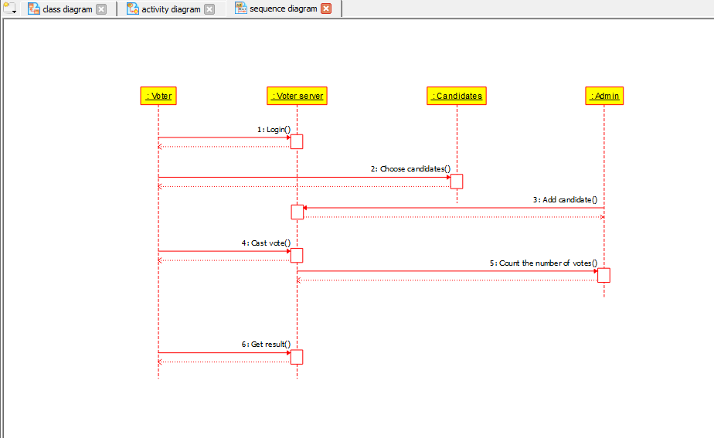

**EX.NO:4 UML DIAGRAM FOR LIBRARY MANAGEMENT SYSTEM**

**USE CASE DIAGRAM:**

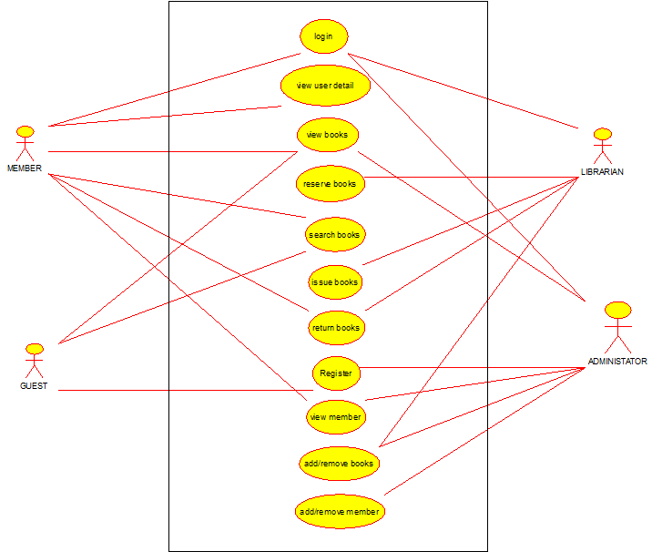

**CLASS DIAGRAM:**

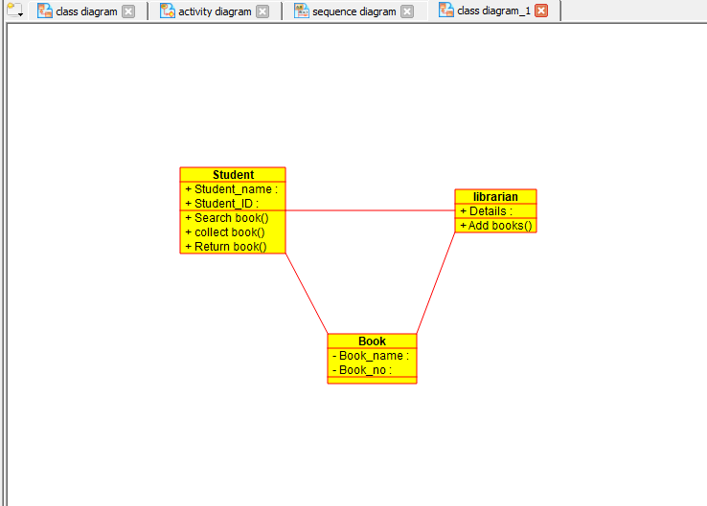

**ACTIVITY DIAGRAM:**

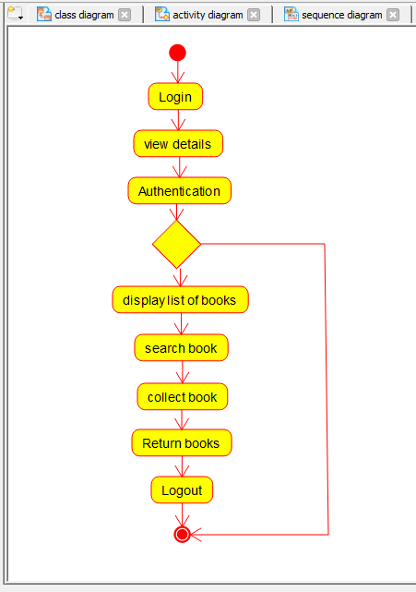

**SEQUENCE DIAGRAM:**

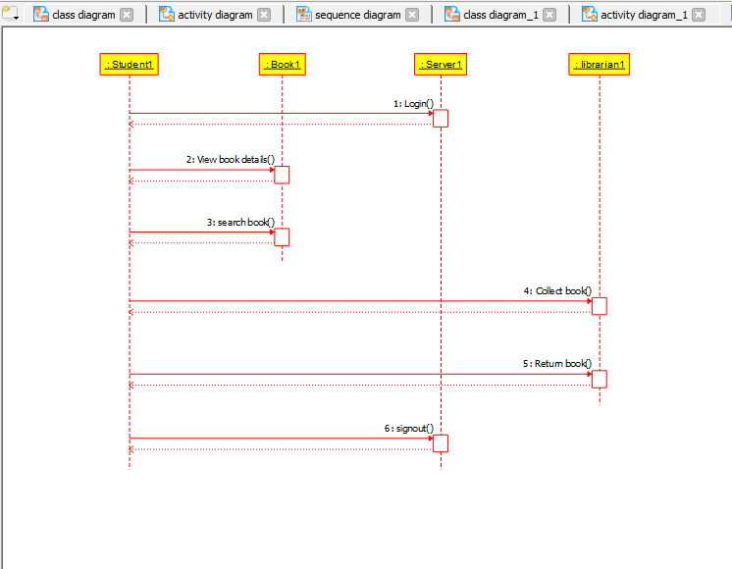

**EX.NO:4 UML DIAGRAM FOR ONLINE SHOPPING SYSTEM**

**USE CASE DIAGRAM:**

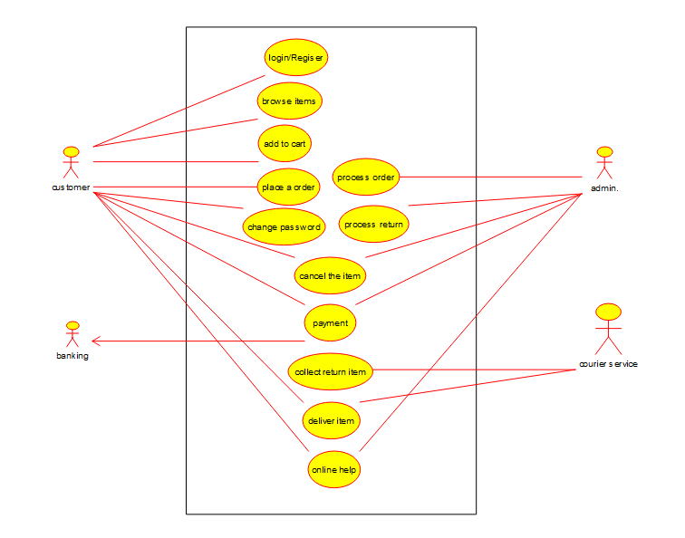

**CLASS DIAGRAM:**

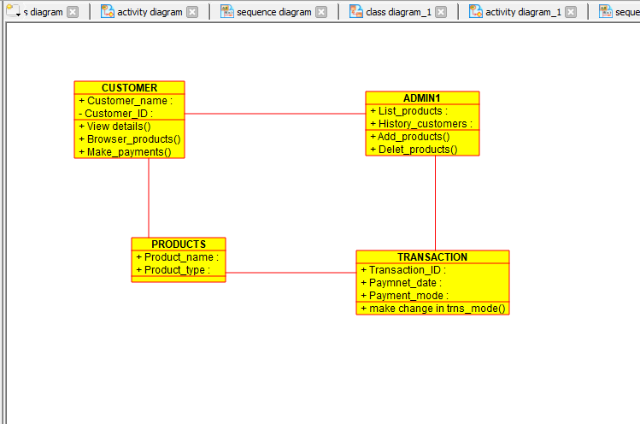

**ACTIVITY DIAGRAM:**

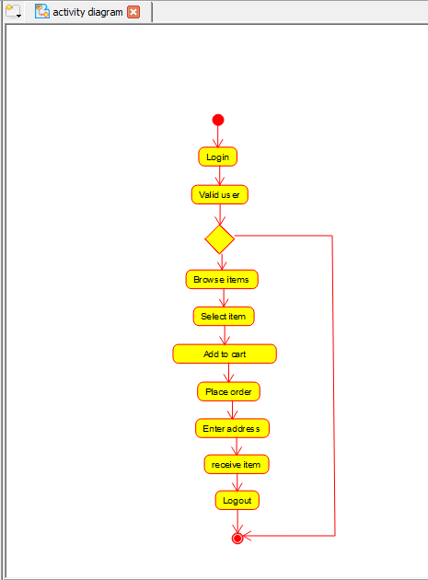

**SEQUENCE DIAGRAM:**

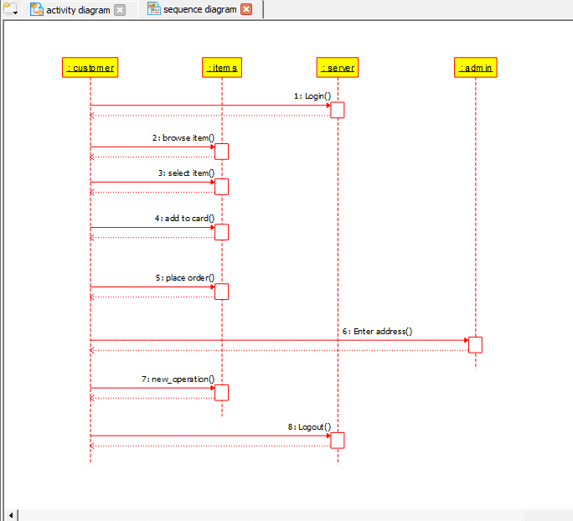

**EX.NO:7A -TO FIND GIVEN NUMBER IS PRIME OR NOT**

**FLOWCHART:**

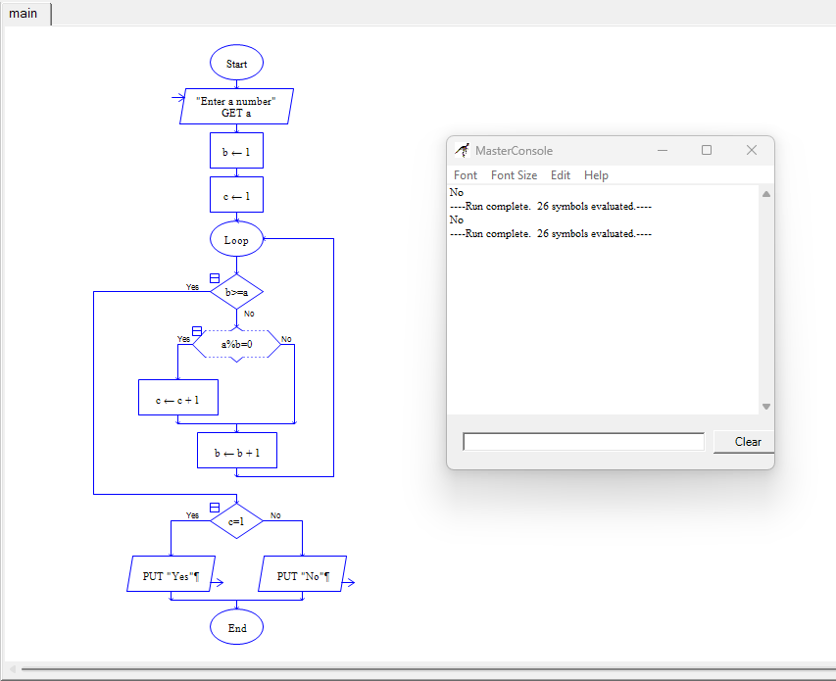

**EX.NO:7B -TO COMPUTE QUOTIENT AND REMAINDER**

**FLOWCHART:**

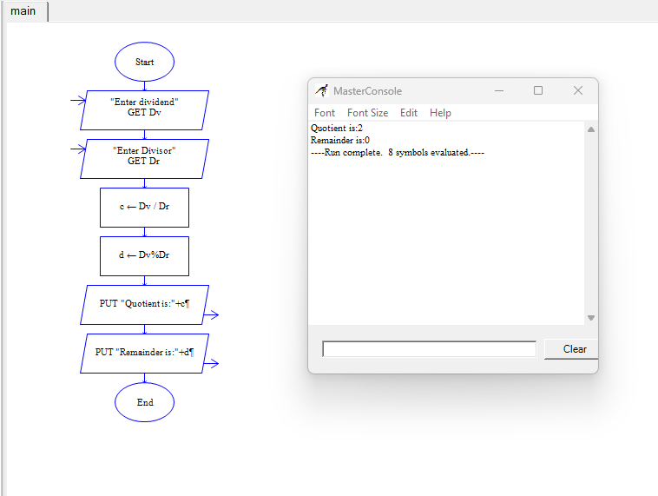

**EX.NO:7C -TO CHECK GIVEN NUMBER IS PALINDROME OR NOT**

**FLOWCHART:**

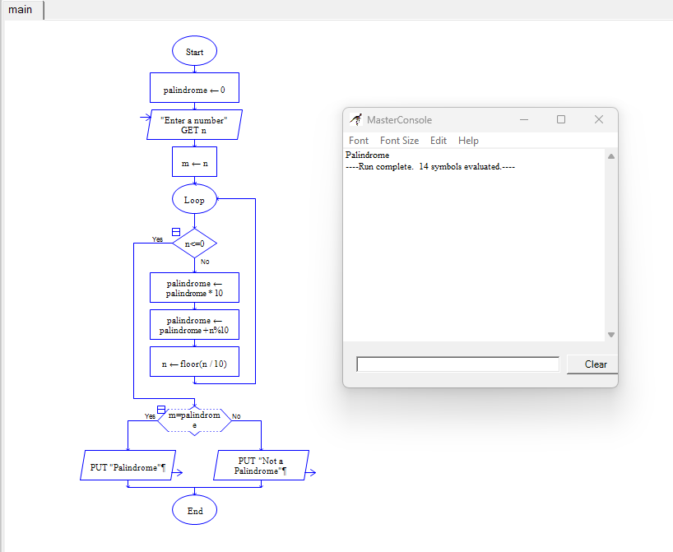

**EX.NO:7C -TO CHECK GIVEN NUMBER IS PALINDROME OR NOT**

**FLOWCHART:**



**EX.NO:7D -TO PRINT AND COUNT VOWELS IN A GIVEN WORD**

**FLOWCHART:**

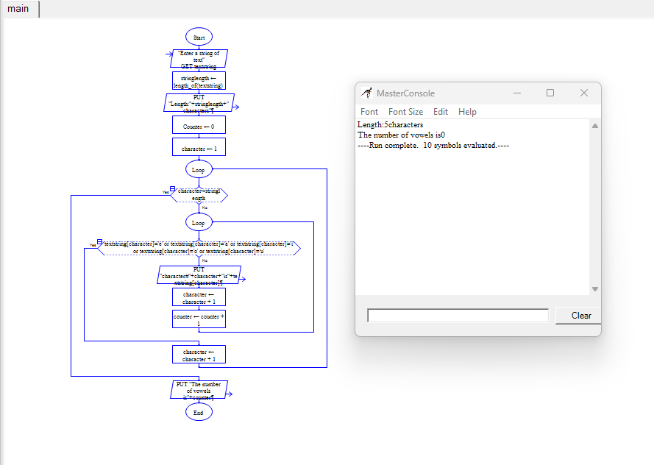

**EX.NO:8A -TO FIND FIBONACCI SERIES**

**FLOWCHART:**

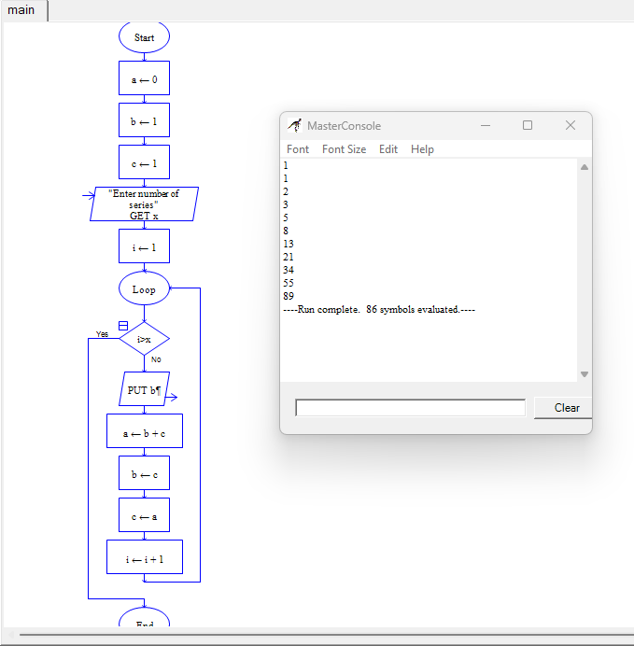

**EX.NO:8B -TO DISPLAY THE POSITION OF THE NUMBERS**

**FLOWCHART:**

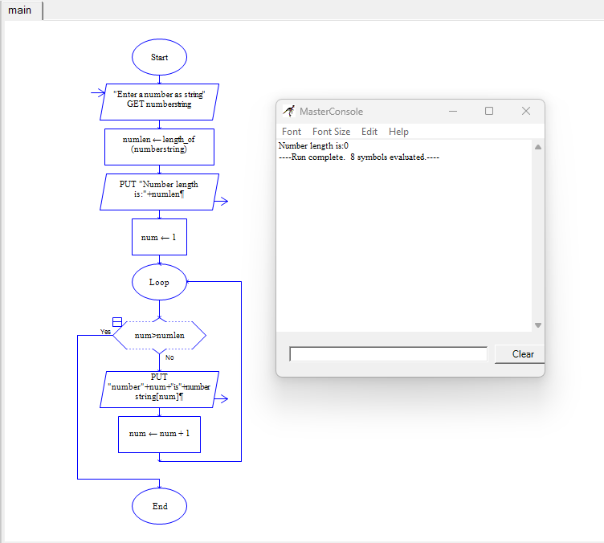

**EX.NO:8C -TO SWAP TWO NUMBERS**

**FLOWCHART:**

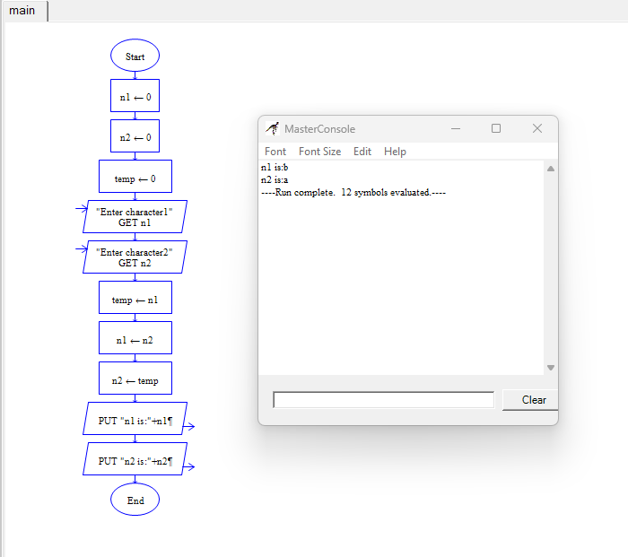

**EX.NO:8D -TO FIND THE GIVEN NUMBER IS AMSTRONG OR NOT**

**FLOWCHART:**

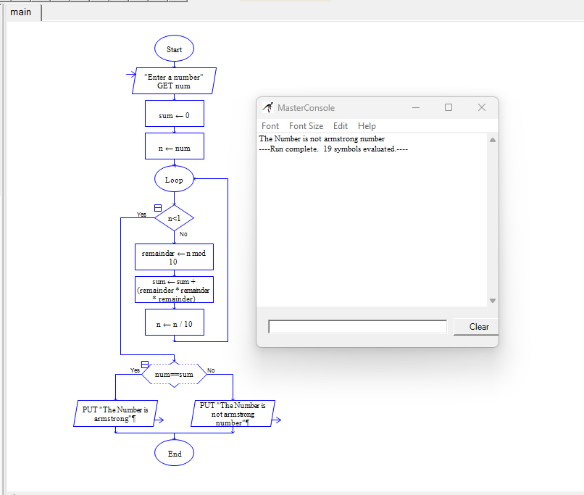

**EX.NO:9B -TO FIND THE GIVEN NUMBER IS PRIME OR NOT**

**FLOWCHART:**

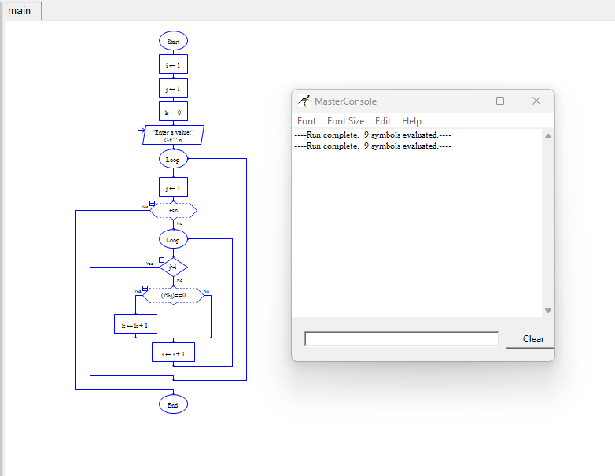

**EX.NO:10B -TO DISPLAY LENGTH OF THE STRING**

**FLOWCHART:**

